Behavioral segmentation (cluster analysis)

Cluster Analysis divides observations in subgroups (clusters), in a way that each cluster has similar observations and is massively heterogeneous from the other subgroups.

Methods of cluster construction
- Partition methods: divide set of observations in predetermined number of non-empty groups
- Hierarchical methods: define hierarchy within subgroups using tree structure and increasing similarity thresholds
- Other methods: graph methods, grid methods,...

Similarity measures
Necessary to define some similarity measures that depend on variables used.
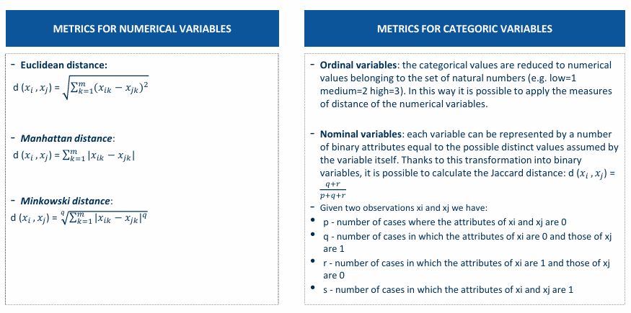

Principal Component Analysis (PCA)
To include a minimal subset of relevant variables. PCA create a linear transformation that allows replacing a set of M numerical variable with a smaller subset of K latent variables, without loss of information

Methodological approach - Partition methods (K-means algorithm)

- initialization: random choice made of observations within dataset that constitute centroids of initial clusters in current iteration
- Each observation assigned to cluster whose centroid most similar to observation
- If no observations are assigned to a different cluster, the algorithm terminates and converge
- Otherwise, new centroid calculated for each cluster as average of observations belonging to cluster and proceed with new iteration (start from point 2)

- Strongly influenced by outliers in the dataset 🙁 → data cleaning before K-means

Methodological approach - Hierarchical methods (bottom-up)
Necessary to overcome the problem of partition methods which require conducting tests and applying posteriori evaluation methods to identify the best solution.
First necessary to define which distance between two clusters to apply between: avg distance, max distance, distance between centroids, Ward distance.

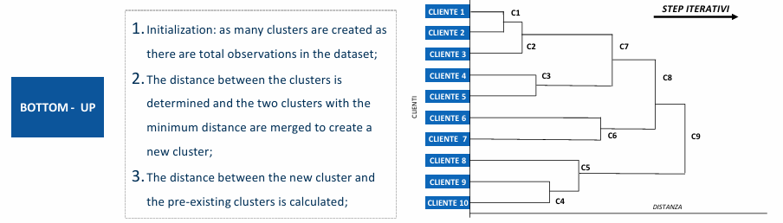

Methodological approach - Hierarchical methods (top-down)

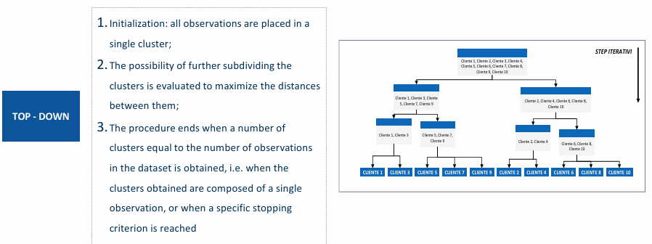

Methodological approach - Evaluation methods

